**Vivekanand Education Society’s Institute of Technology**

**Department of AI&DS Engineering**



**Subject: Social Media Analytics**

**Class: D16AD**

| ROLL NO: **30** | NAME: [**SUHANEE KANDALKAR**](mailto:2021.suhanee.kandalkar@ves.ac.in) | | |
| --- | --- | --- | --- |
| EXPERIMENT NO:**1A** | TITLE:Social Media Analytics Basics | | |
| DOP:20/1/24 |  | DOS: |  |
| GRADES: | LOs MAPPED: | | SIGNATURE: |

**Aim :**

To Study the google trends for the chosen problem statement in social media analytics and compare its Presence / Rankings in various social media platforms. Compare various SMA tools and engagement metrics.

**Results :**

Analysis of Productivity tools over *worldwide :*

## **Google Trends**

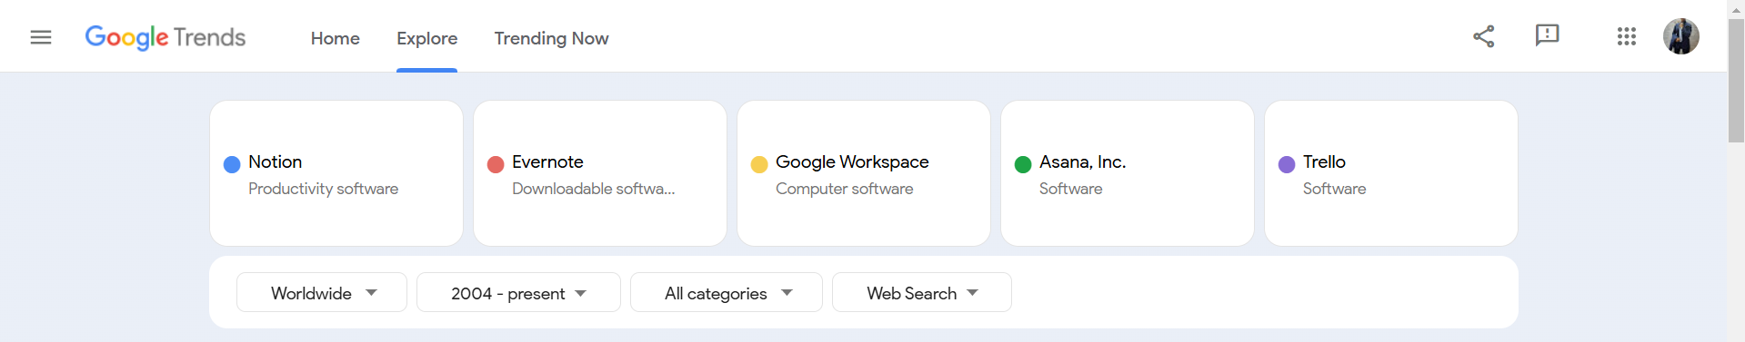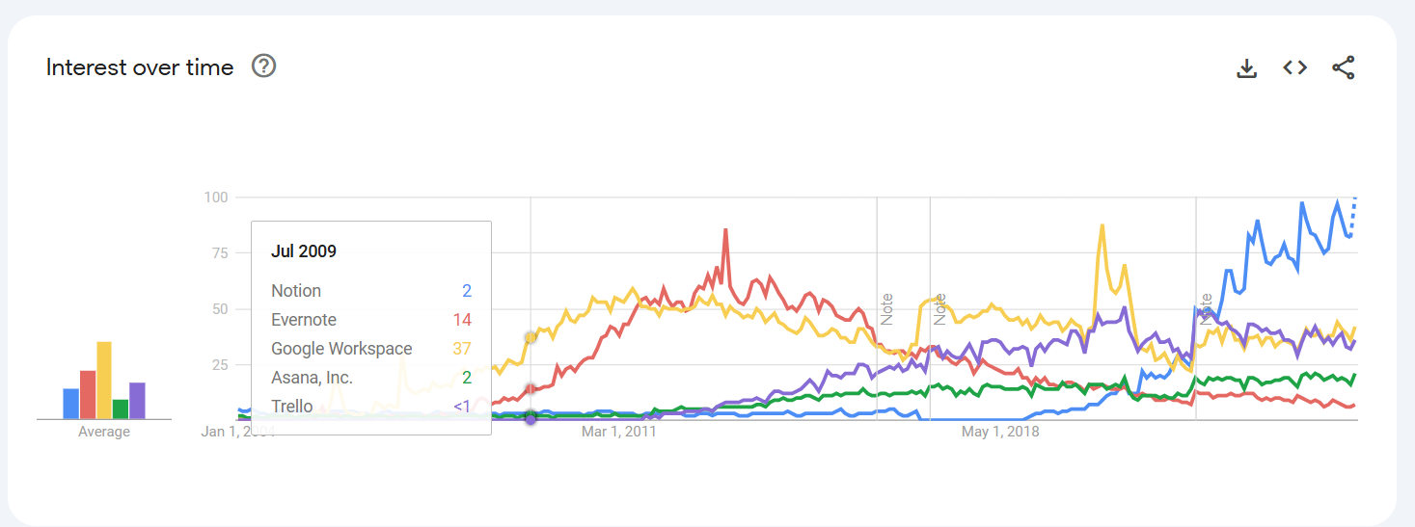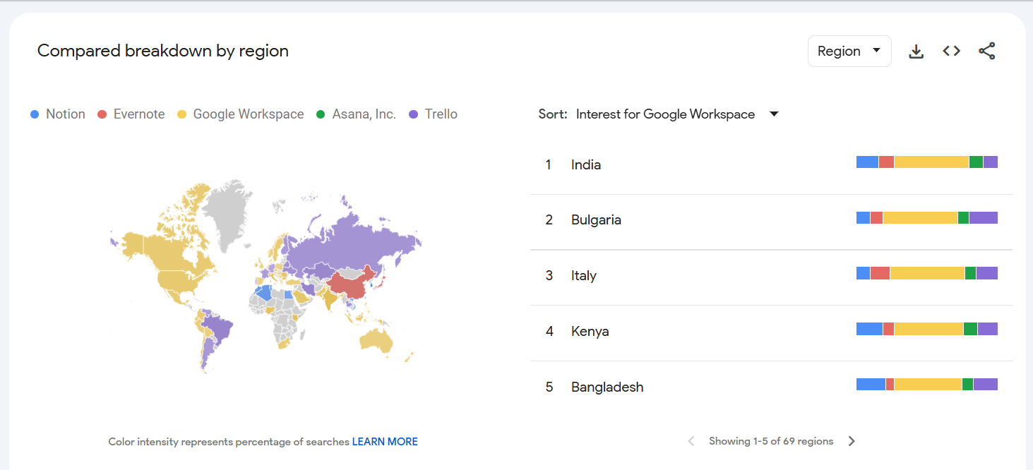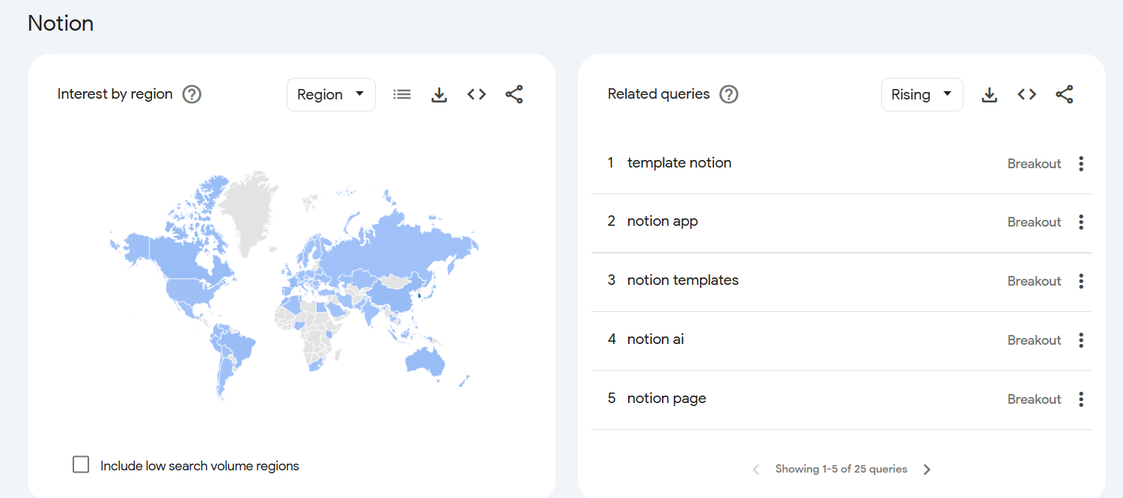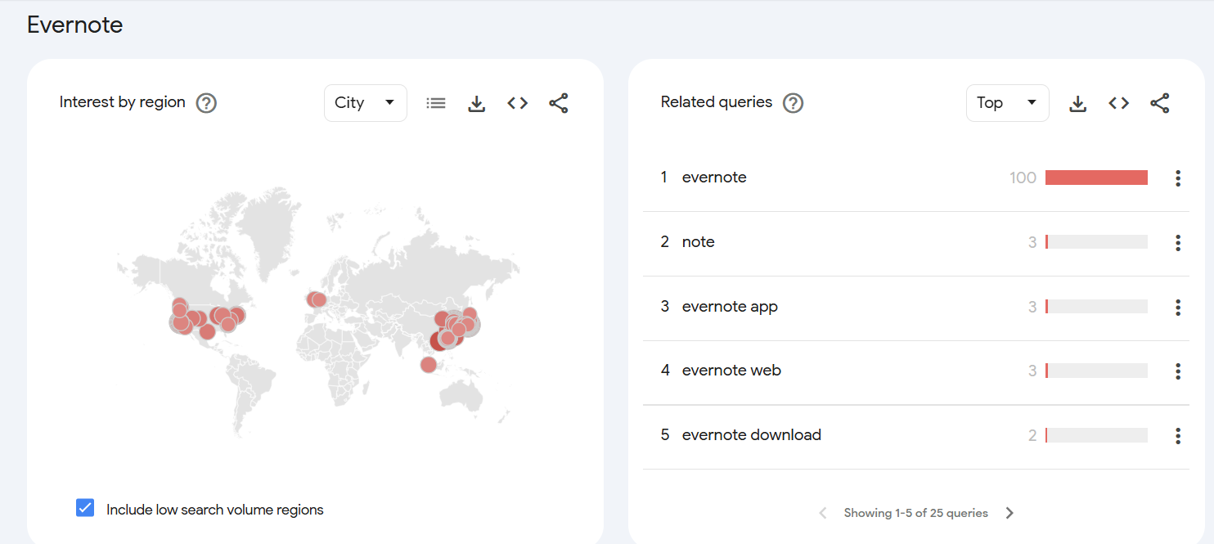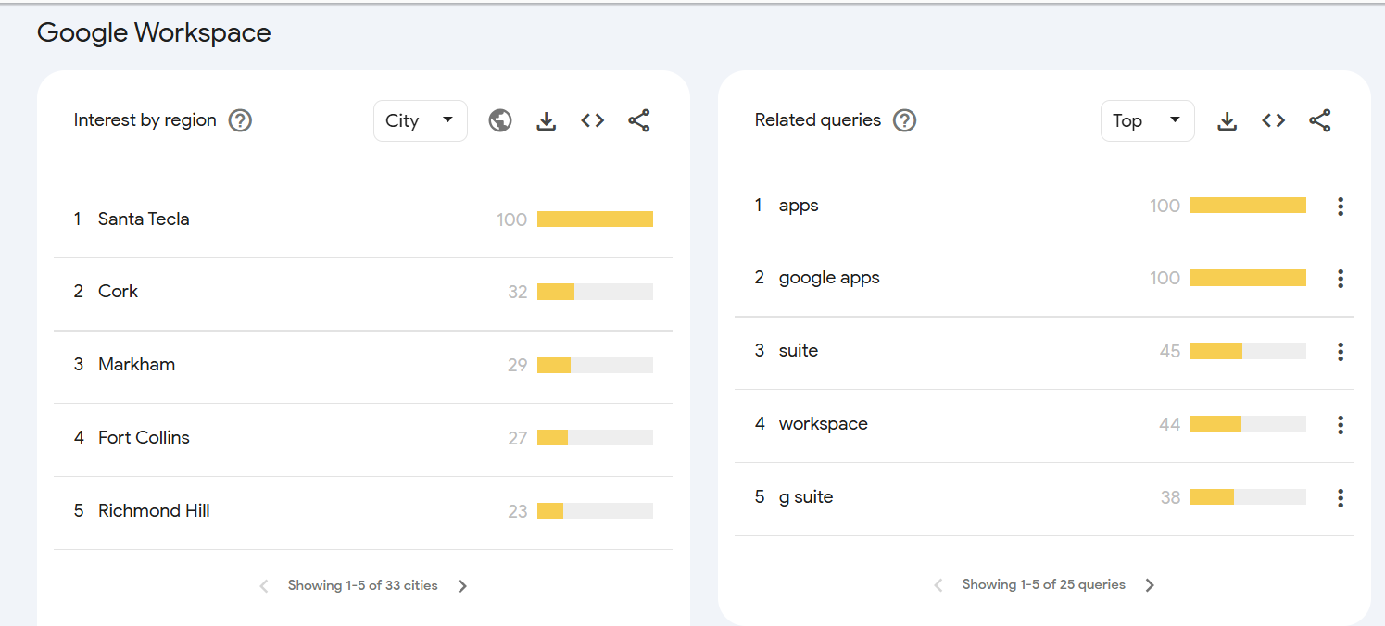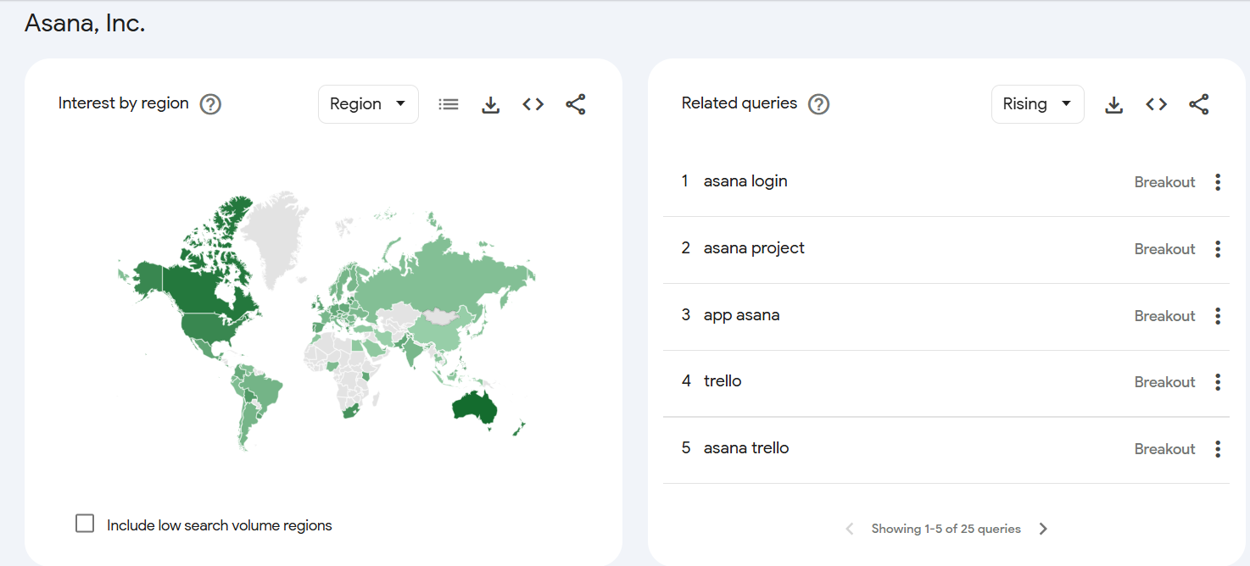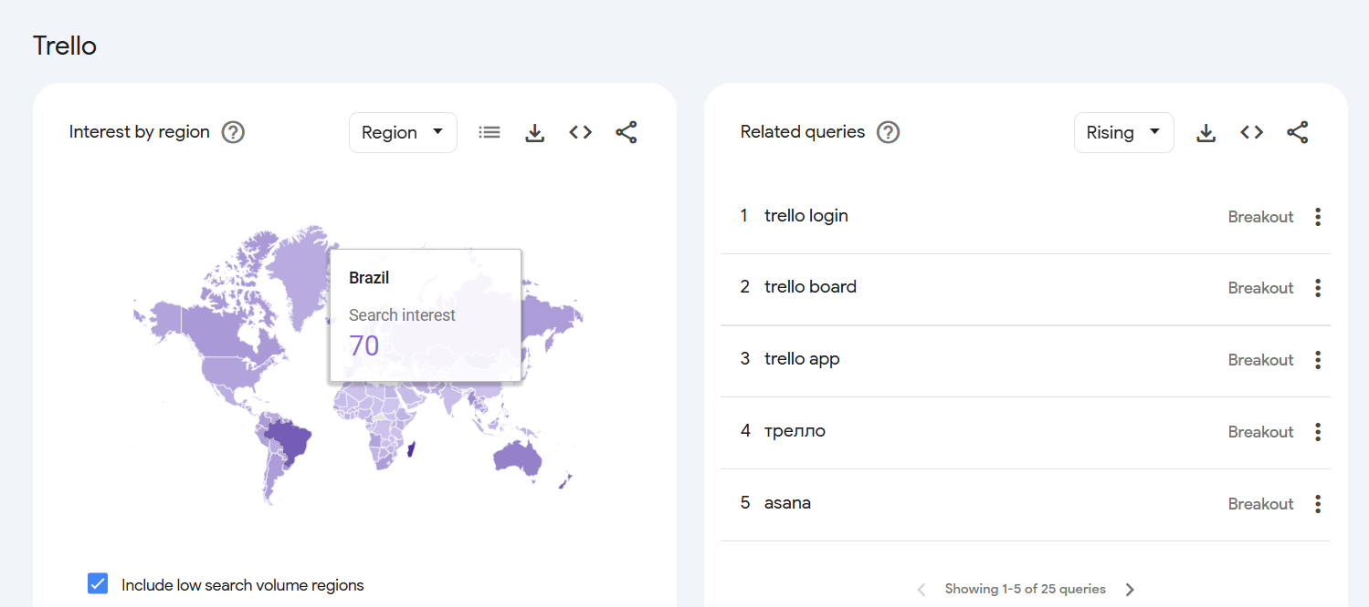

## 

## 

## **Brand24**

Brand outreach of Google Workspace.

Google Workspace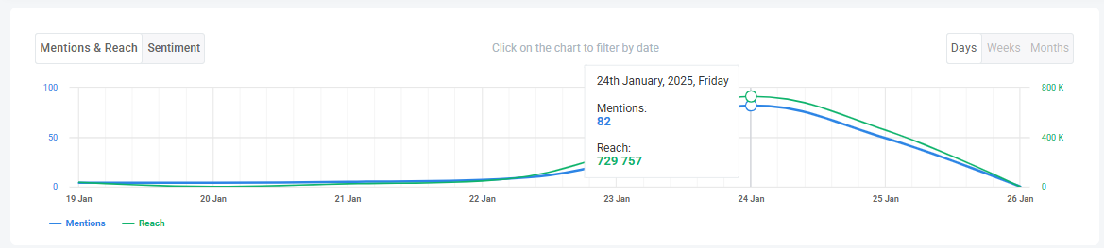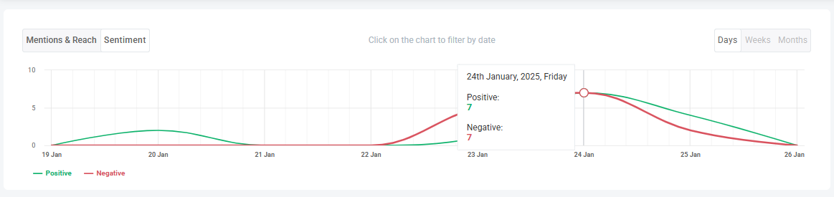

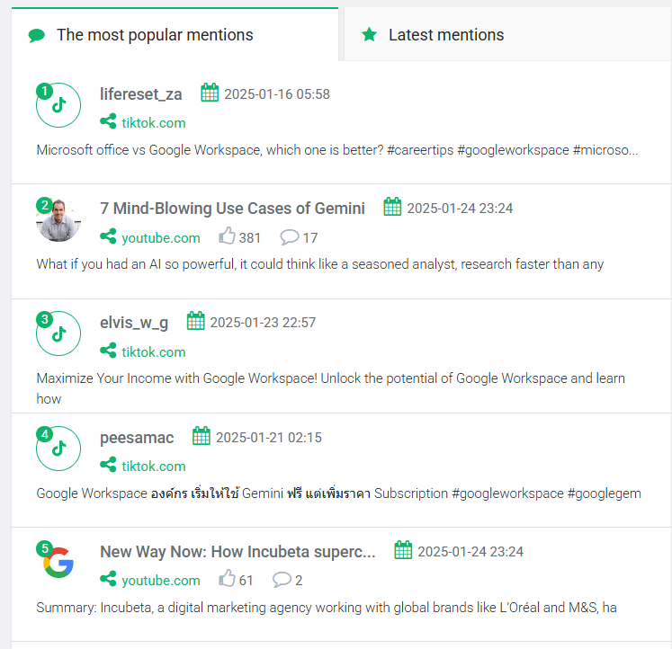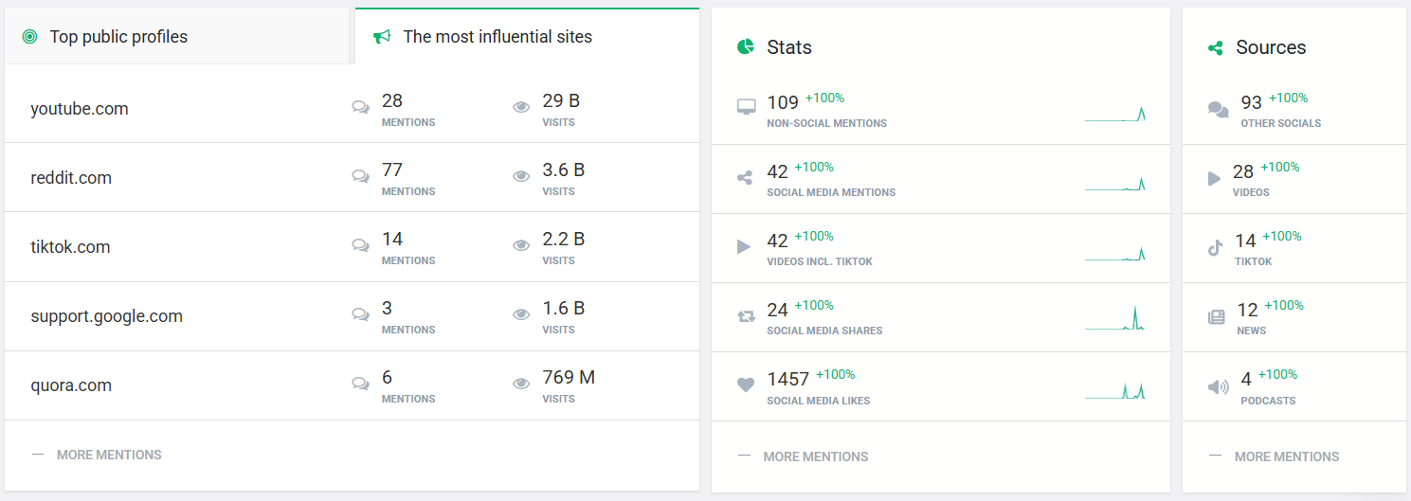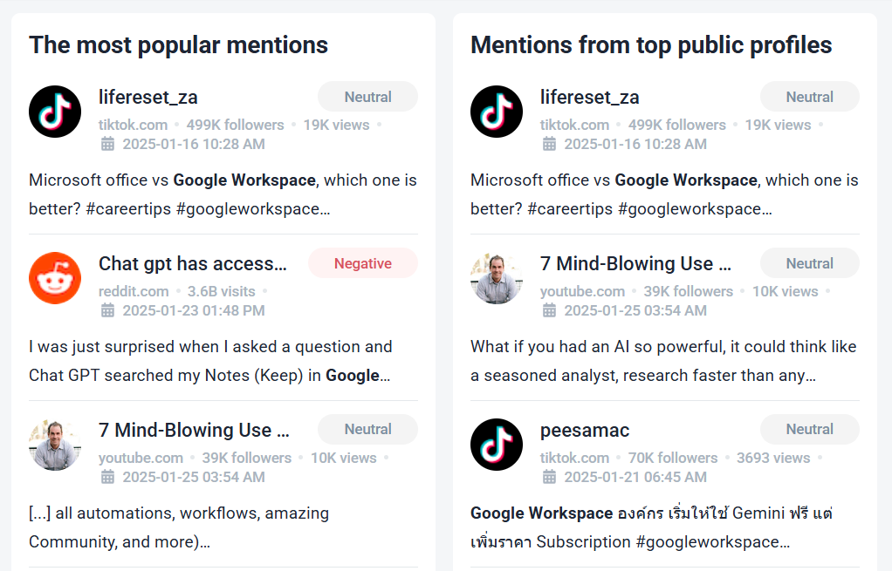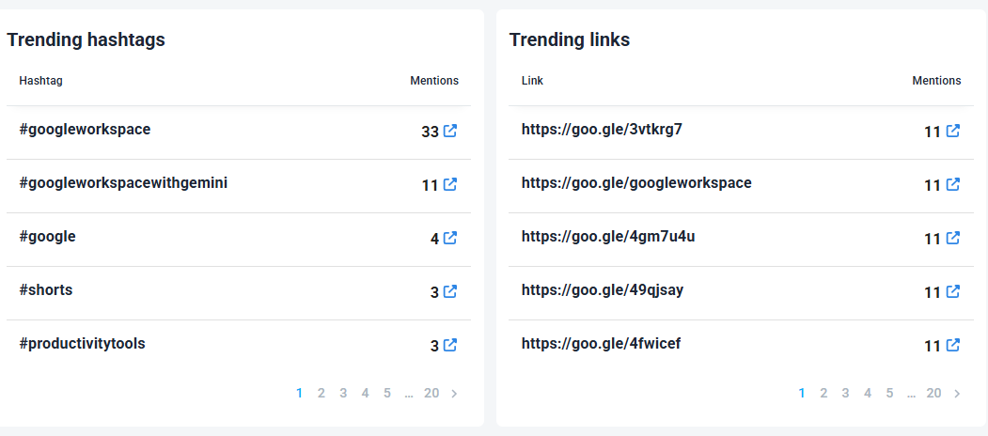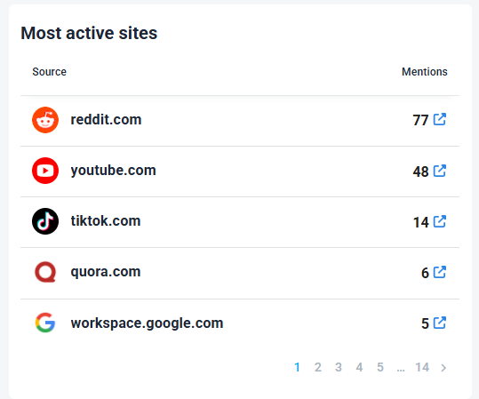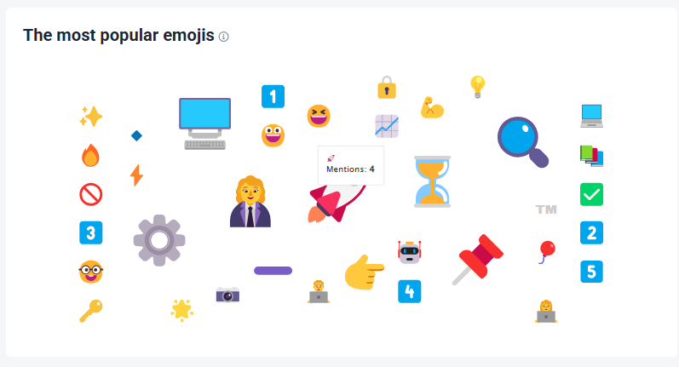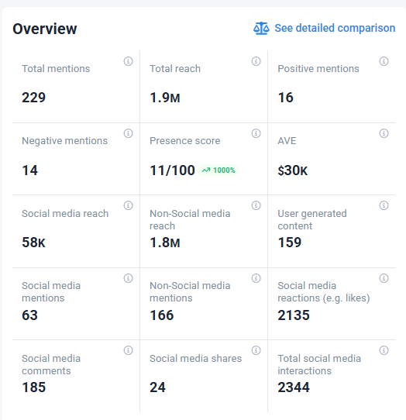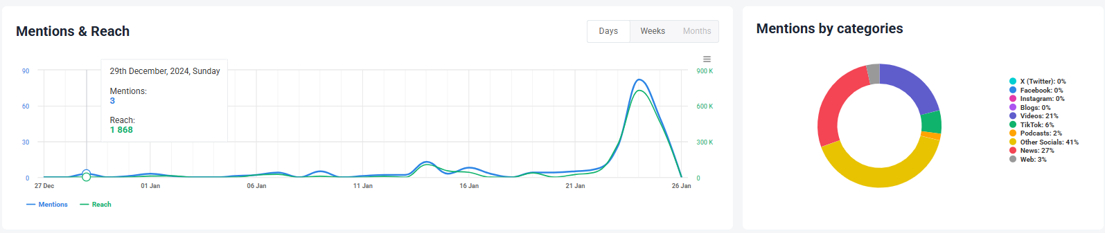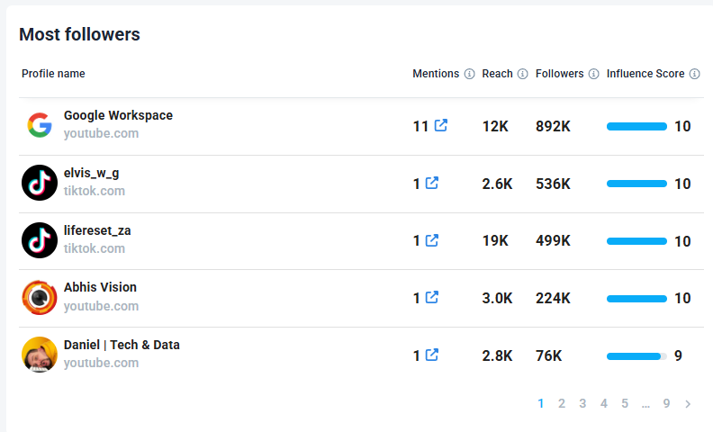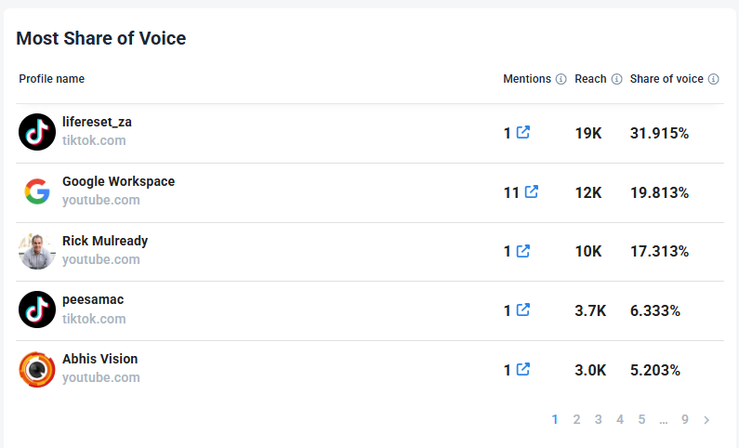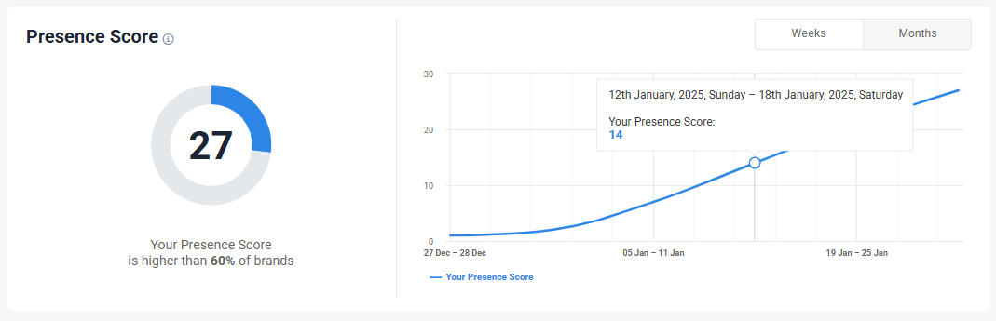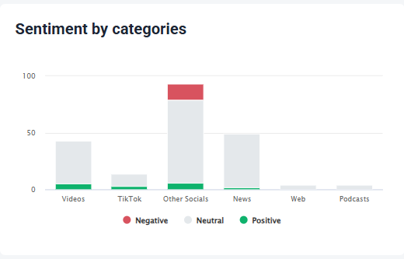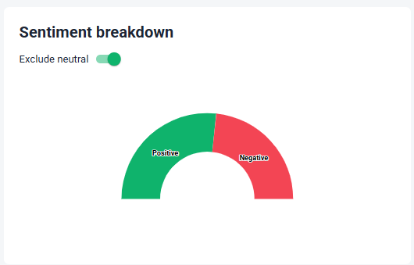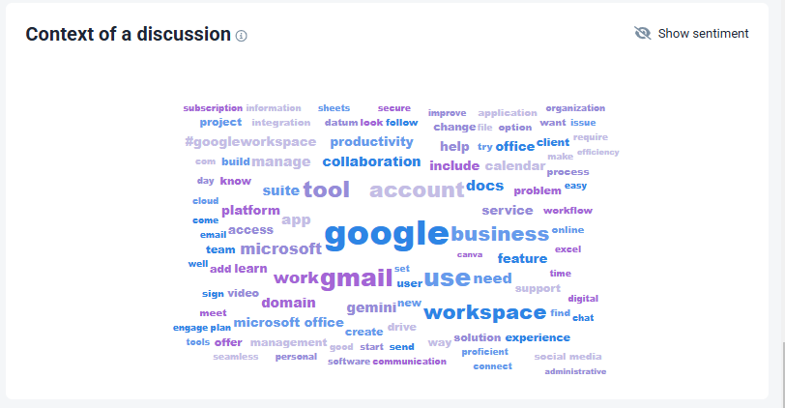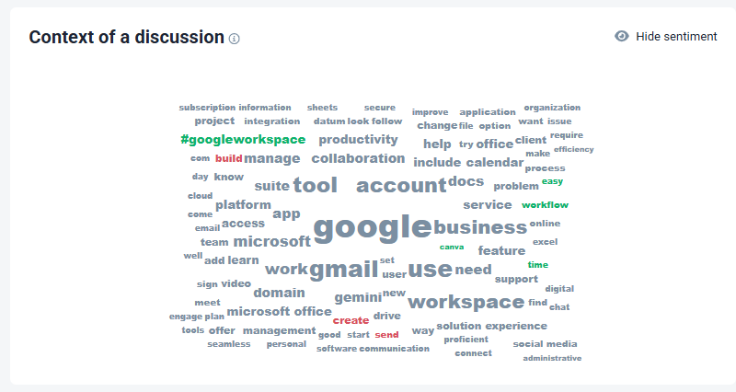

### **Conclusion**

* Brand24 is best for social media analytics, sentiment tracking, and influencer marketing.
* Google Trends is ideal for trend forecasting, keyword research, and search behavior analysis.